**Land Use Land Cover Classification**

**Image Analysis Assignment-2**

**By**

**Priya Kumari**

**S6043321**

# Introduction

The image obtained from the satellite consists of different kind of errors like noise, any distortion in the image or problem, in contrast, we cannot use the image directly so in order to make the proper use of the image we need to perform

# Objectives

To use the different types of filters and segmentation of image and then classify the image using decision tree classifier

1. Image filtering - To determine the best filter which can give a better result.
2. Image Segmentation – to recognize the segmented part the image and discuss the result.
3. Image classification – to classify the image into different classes and recognize the classes

# Study area

* **District -Yanam**
* Coordinates-16.7272° N, 82.2176° E
* Union territory-Puducherry
* Country- India

It is located at the eastern part of the Godavari river near Andhra Pradesh southern part of India it is a part of the union territory Puducherry

This area is very versatile in landscape area located near the Godavari bank forming the delta near the Bay of Bengal have consists of different major classes .like mangrove forest, ocean , river ,cropland , dry land, etc.

# Dataset used

* Landsat-5
* Date of acquisition-2008-04-26
* Bands- Band-1(Blue)

Band-2(Green)

Band-3(Red)

Band-4(NIR

* Spatial resolution – 30m
* Radiometric resolution- 8 bit

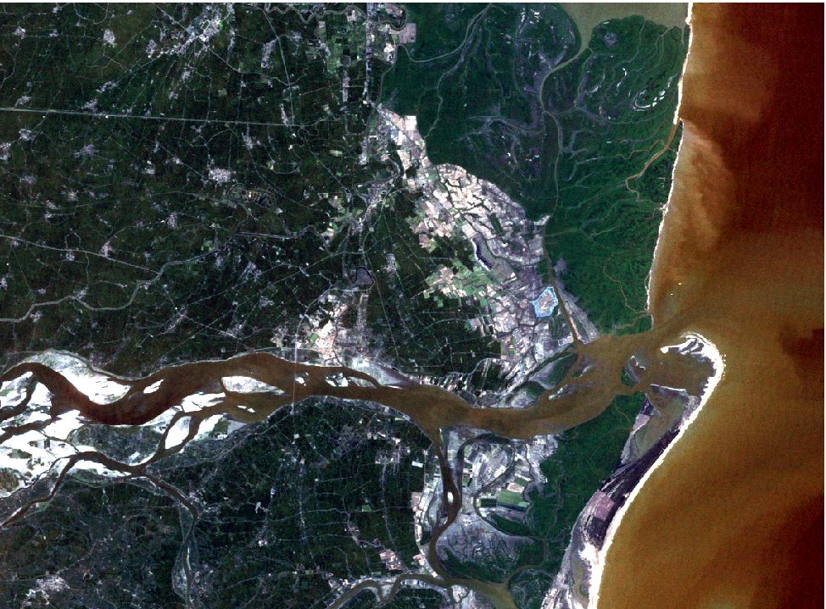

Landsat -5 image of the Yanam, India

# Methodology

Landsat-5 image

Image segmentation

Using mean shift varience

Training data and class aloted

Converting image into grayscale image

Histogram stretching

Mean shift segmentation

Created decision tree

Classified image (4 major classes)

Sobel filter

Predicting land use land cover classes

Accuracy level 98.2%

The edge of the river and dry land visible

## 5.1 Image filtering

**Sobel filter**

Sobel filter is used to do identify the edges boundaries of sand deposit boundary in river bed, when experimenting with all filters Sobel filter gave best results comparing to all the filters Sobel filter gave better results with the boundaries of sand deposits in river basin. The size of the kernel in the filter is 3x3 it is the best kernel giving good results.

size edge deduction in the image, this filter is less sensitive to noise as compared to Roberts filter in the output image we can see the edge of the water and the drylands very prominent near the river & even at the ocean shores.

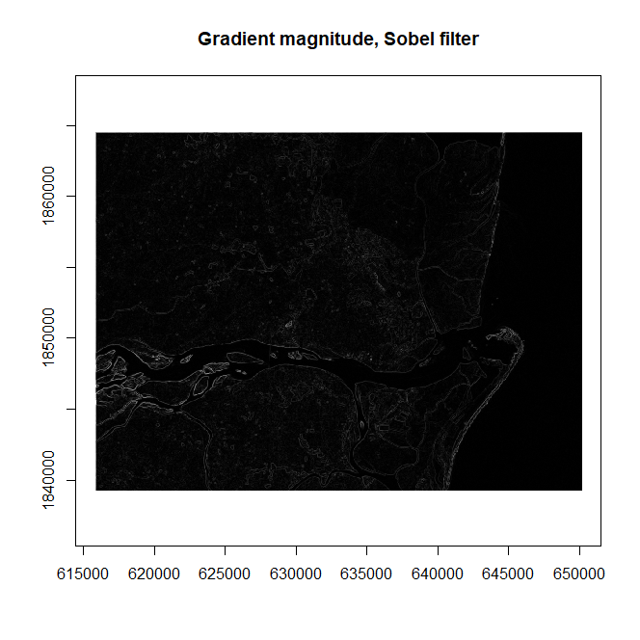

## 5.2 Image segmentation

**Mean shift segmentation**

The image is segmented into forest , water, dryland and built up mainly into four major class but the forest area is segmented into 2 types i.e one have dense vegetation and the other have lighter vegetation & also the built-up area are not prominently visible.

To classify the study area into more classes the bandwidth is changed to 0.01 and neighbors is 7, while the band width is increased to higher number the number of classes are decreasing.

**Mean shift**

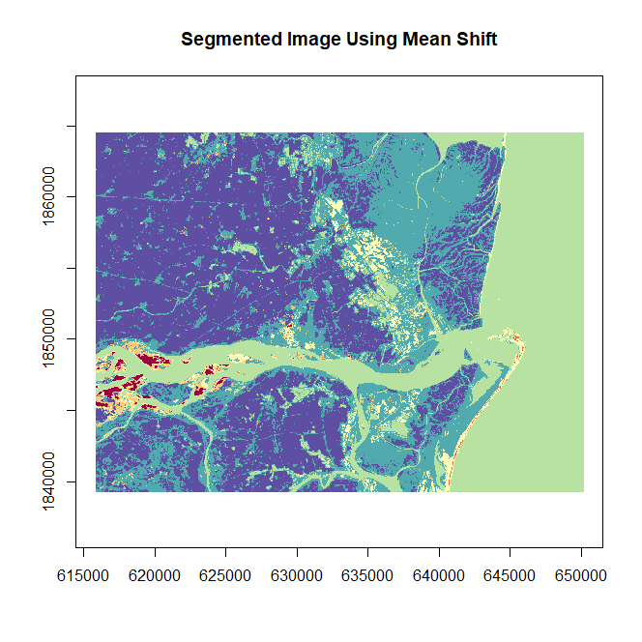

## 5.3 Classification

For the land use, land cover classification of the image decision tree classifier is used .the training samples of the five major classes like forest,water, built up, dry land ,& cropland in the image. 2000 training samples points were selected in the entire study area then the respected classes and spectral values are assigned to those 2000 points, using those sample points the decision tree is created to classify the entire image into LULC classes

Decision tree obtained used for the prediction of the classes

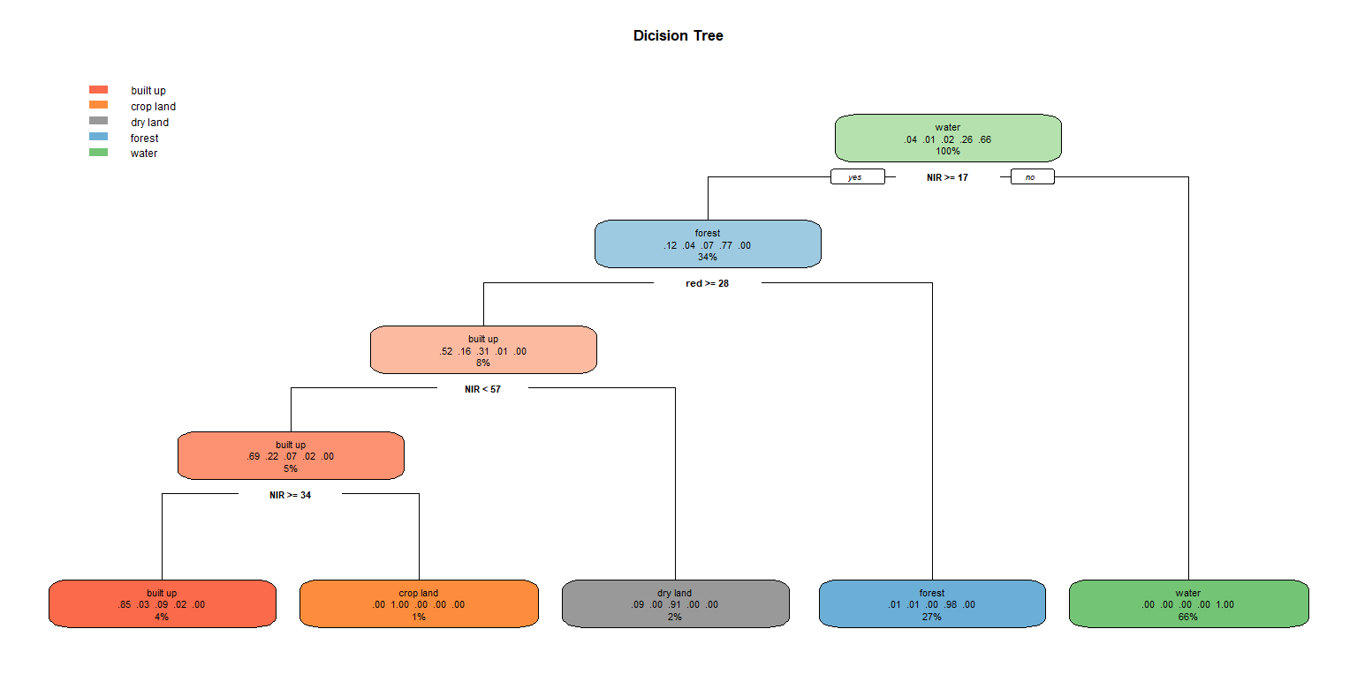

|  |  |  |  |  |  |
| --- | --- | --- | --- | --- | --- |
| observed | builtup | crop Land | dry Land | forest | water |
| builtup | 72 | 0 | 6 | 4 | 0 |
| crop Land | 1 | 20 | 2 | 4 | 0 |
| dry Land | 12 | 0 | 32 | 0 | 0 |
| forest | 2 | 2 | 2 | 523 | 0 |
| water | 0 | 0 | 0 | 0 | 1313 |

**Predicted values**

**Classified image**

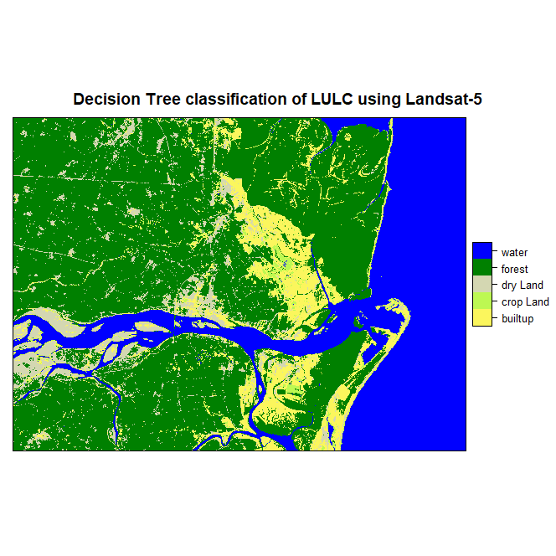

# Reflection

* Sobel filter gave the better results compared to all the results from other edge detection filters because Sobel filter adding weights to the nearest pixels values in the kernel.
* Mean shift segmentation gave better result for 4 types of segments by changing the bin width compared to decision tree result mean shift segmentation gave very small classes.
* In classification decision tree classifier gives better result than the other classifier up to 98.2% of accuracy obtained